Supplementary Information
Schizophrenia classification from multichannel EEG using EEGNet with SHAP and Grad-CAM
Supporting results for the revised manuscript

Purpose. This file contains detailed results from the controlled model checks, bootstrap analysis, ICA artifact check, and updated SHAP and Grad-CAM analysis. The main manuscript contains only the short results needed to explain the study clearly. The detailed tables and figures are placed here so that readers can examine the full supporting evidence.
Important note. The learning-rate and STFT tests below are sensitivity checks. They were not used to select a new headline result after looking at the held-out test data. The main manuscript uses the pre-specified reference settings: learning rate 0.00005 and STFT nperseg = 64 for the 3D-CNN, and learning rate 0.0005 for EEGNet.
Abbreviations. HC, healthy control; SZ, schizophrenia; LOSO, Leave-One-Subject-Out; ICA, Independent Component Analysis; STFT, Short-Time Fourier Transform; AUC, area under the ROC curve; IQR, interquartile range.

Contents
- Table S1. Complete 3D-CNN learning-rate and STFT sensitivity results
- Table S2. Complete EEGNet learning-rate sensitivity results
- Table S3. Paired bootstrap comparison of EEGNet and 3D-CNN
- Table S4. Fold and subject results at the reference settings
- Table S5. Subject-by-subject changes after ICA cleaning
- Table S6. ICA components removed from the 28 subjects
- Table S7. Full SHAP and Grad-CAM comparison before and after ICA cleaning
- Supplementary Figures S1 to S12

Table S1. Complete 3D-CNN sensitivity results
Table S1. Complete controlled 3D-CNN results across three learning rates and three STFT settings.
Validation | Learning rate | nperseg | Frequency x time | Epoch accuracy | Epoch Kappa | Epoch AUC | Subject accuracy | Subject Kappa | Subject AUC | Fold accuracy mean | Fold SD | Fold IQR
LOSO | 0.00005 | 32 | 6 x 14 | 0.5636 | 0.1479 | 0.6242 | 0.6786 | 0.3571 | 0.6990 | 0.5643 | 0.2834 | 0.5458
LOSO | 0.00005 | 64 | 11 x 6 | 0.5445 | 0.1019 | 0.5984 | 0.5714 | 0.1429 | 0.6684 | 0.5587 | 0.2737 | 0.3776
LOSO | 0.00005 | 128 | 21 x 2 | 0.5682 | 0.1519 | 0.6449 | 0.6786 | 0.3571 | 0.8010 | 0.5816 | 0.2859 | 0.3826
LOSO | 0.0005 | 32 | 6 x 14 | 0.6240 | 0.2569 | 0.7157 | 0.7857 | 0.5714 | 0.8112 | 0.6152 | 0.3386 | 0.6413
LOSO | 0.0005 | 64 | 11 x 6 | 0.6738 | 0.3467 | 0.6465 | 0.7143 | 0.4286 | 0.7143 | 0.6632 | 0.3029 | 0.3932
LOSO | 0.0005 | 128 | 21 x 2 | 0.6169 | 0.2380 | 0.6795 | 0.6786 | 0.3571 | 0.7806 | 0.6059 | 0.2851 | 0.4000
LOSO | 0.005 | 32 | 6 x 14 | 0.5447 | 0.0801 | 0.5769 | 0.6429 | 0.2857 | 0.6582 | 0.5440 | 0.3128 | 0.5167
LOSO | 0.005 | 64 | 11 x 6 | 0.5399 | 0.0830 | 0.4989 | 0.5714 | 0.1429 | 0.5153 | 0.5551 | 0.3130 | 0.5339
LOSO | 0.005 | 128 | 21 x 2 | 0.5094 | 0.0211 | 0.5128 | 0.5357 | 0.0714 | 0.5357 | 0.5112 | 0.2451 | 0.2597
Stratified 5-Fold | 0.00005 | 32 | 6 x 14 | 0.5568 | 0.1016 | 0.5898 | 0.5357 | 0.0714 | 0.6224 | 0.5638 | 0.1360 | 0.2058
Stratified 5-Fold | 0.00005 | 64 | 11 x 6 | 0.5102 | 0.0112 | 0.4877 | 0.5714 | 0.1429 | 0.5255 | 0.5115 | 0.0445 | 0.0656
Stratified 5-Fold | 0.00005 | 128 | 21 x 2 | 0.4605 | -0.0839 | 0.4531 | 0.4643 | -0.0714 | 0.4388 | 0.4609 | 0.0284 | 0.0094
Stratified 5-Fold | 0.0005 | 32 | 6 x 14 | 0.4911 | -0.0100 | 0.5081 | 0.4643 | -0.0714 | 0.4592 | 0.4943 | 0.0739 | 0.0888
Stratified 5-Fold | 0.0005 | 64 | 11 x 6 | 0.5825 | 0.1300 | 0.5882 | 0.6071 | 0.2143 | 0.6173 | 0.5848 | 0.0939 | 0.1350
Stratified 5-Fold | 0.0005 | 128 | 21 x 2 | 0.4694 | -0.0675 | 0.4745 | 0.4643 | -0.0714 | 0.5255 | 0.4681 | 0.0750 | 0.0802
Stratified 5-Fold | 0.005 | 32 | 6 x 14 | 0.5854 | 0.1545 | 0.6145 | 0.5714 | 0.1429 | 0.7143 | 0.5842 | 0.1421 | 0.2047
Stratified 5-Fold | 0.005 | 64 | 11 x 6 | 0.5539 | 0.1044 | 0.5814 | 0.6071 | 0.2143 | 0.6122 | 0.5573 | 0.0930 | 0.0696
Stratified 5-Fold | 0.005 | 128 | 21 x 2 | 0.4945 | -0.0078 | 0.5254 | 0.5357 | 0.0714 | 0.6071 | 0.4922 | 0.0992 | 0.1537
The reference setting used in the main manuscript is learning rate 0.00005 with nperseg = 64. The remaining rows are sensitivity checks. The values show that changing the learning rate or STFT resolution did not make the 3D-CNN consistently reliable under both validation methods.

Table S2. Complete EEGNet learning-rate sensitivity results
Table S2. Complete controlled EEGNet results across the three tested learning rates.
Validation | Learning rate | Epoch accuracy | Epoch Kappa | Epoch AUC | Subject accuracy | Subject Kappa | Subject AUC | Fold accuracy mean | Fold SD | Fold IQR
LOSO | 0.00005 | 0.6195 | 0.2368 | 0.7022 | 0.5357 | 0.0714 | 0.7143 | 0.6245 | 0.2711 | 0.5093
LOSO | 0.0005 | 0.7496 | 0.4967 | 0.7967 | 0.7857 | 0.5714 | 0.9082 | 0.7508 | 0.2408 | 0.3630
LOSO | 0.005 | 0.7281 | 0.4519 | 0.7851 | 0.7143 | 0.4286 | 0.8520 | 0.7309 | 0.2896 | 0.4493
Stratified 5-Fold | 0.00005 | 0.6583 | 0.3104 | 0.7193 | 0.6786 | 0.3571 | 0.7857 | 0.6610 | 0.1039 | 0.1075
Stratified 5-Fold | 0.0005 | 0.6787 | 0.3569 | 0.7574 | 0.7143 | 0.4286 | 0.8010 | 0.6795 | 0.1370 | 0.1841
Stratified 5-Fold | 0.005 | 0.7309 | 0.4565 | 0.7945 | 0.7143 | 0.4286 | 0.8724 | 0.7284 | 0.1097 | 0.0693
The reference learning rate used in the main manuscript is 0.0005. Kappa remained positive at all three tested learning rates under both validation methods.

Table S3. Paired bootstrap comparison of EEGNet and 3D-CNN
Table S3. Difference between EEGNet and 3D-CNN at the reference settings using 10,000 paired subject resamples.
Validation | Metric | 3D-CNN | EEGNet | EEGNet minus 3D-CNN | 95% confidence interval of difference
Stratified 5-Fold | Accuracy | 0.510 | 0.679 | +0.169 | [+0.021, +0.328]
Stratified 5-Fold | F1-score | 0.553 | 0.695 | +0.142 | [-0.018, +0.339]
Stratified 5-Fold | Cohen's Kappa | 0.011 | 0.357 | +0.346 | [+0.060, +0.654]
Stratified 5-Fold | AUC | 0.488 | 0.757 | +0.270 | [+0.104, +0.445]
LOSO | Accuracy | 0.544 | 0.750 | +0.205 | [+0.076, +0.335]
LOSO | F1-score | 0.532 | 0.767 | +0.234 | [+0.087, +0.399]
LOSO | Cohen's Kappa | 0.102 | 0.497 | +0.395 | [+0.141, +0.649]
LOSO | AUC | 0.598 | 0.797 | +0.198 | [+0.070, +0.325]
A positive difference means that EEGNet had the larger value. The interval for Stratified 5-Fold F1-score includes zero, while the intervals for the other listed comparisons remain above zero.

Table S4. Fold and subject results at the reference settings
Table S4A. Stratified Group 5-Fold results for each test fold at the reference settings.
Model | Fold | Test subjects | Epoch accuracy | Kappa | AUC | Seed | Test epochs
3D-CNN | 1 | H01;H02;H03;S01;S02;S03 | 0.480 | -0.005 | 0.495 | 42 | 5699
3D-CNN | 2 | H04;H05;H06;S04;S05;S06 | 0.492 | -0.014 | 0.462 | 43 | 5635
3D-CNN | 3 | H07;H08;H09;S07;S08;S09 | 0.546 | -0.006 | 0.469 | 44 | 6167
3D-CNN | 4 | H10;H11;H12;S10;S11;S12 | 0.469 | -0.087 | 0.408 | 45 | 6227
3D-CNN | 5 | H13;H14;S13;S14 | 0.571 | 0.007 | 0.501 | 46 | 5135
EEGNet | 1 | H01;H02;H03;S01;S02;S03 | 0.748 | 0.494 | 0.838 | 42 | 5699
EEGNet | 2 | H04;H05;H06;S04;S05;S06 | 0.873 | 0.747 | 0.959 | 43 | 5635
EEGNet | 3 | H07;H08;H09;S07;S08;S09 | 0.672 | 0.317 | 0.709 | 44 | 6167
EEGNet | 4 | H10;H11;H12;S10;S11;S12 | 0.541 | 0.080 | 0.533 | 45 | 6227
EEGNet | 5 | H13;H14;S13;S14 | 0.564 | 0.180 | 0.638 | 46 | 5135
The same five subject groups and the same fold seeds were used for the two models. Fold 3 contains H07, H08, H09, S07, S08 and S09.
Table S4B. Held-out subject results at the reference settings.
Subject | Class | 3D-CNN LOSO: epoch accuracy; subject result | 3D-CNN Stratified: epoch accuracy; subject result | EEGNet LOSO: epoch accuracy; subject result | EEGNet Stratified: epoch accuracy; subject result
H01 | HC | 92.1%; correct | 95.5%; correct | 90.4%; correct | 89.6%; correct
H02 | HC | 48.6%; wrong | 96.6%; correct | 57.7%; correct | 38.7%; wrong
H03 | HC | 92.5%; correct | 97.3%; correct | 90.5%; correct | 87.0%; correct
H04 | HC | 45.0%; wrong | 60.0%; correct | 98.3%; correct | 97.7%; correct
H05 | HC | 44.8%; wrong | 79.7%; correct | 94.7%; correct | 97.9%; correct
H06 | HC | 98.6%; correct | 57.6%; correct | 98.3%; correct | 99.4%; correct
H07 | HC | 45.2%; wrong | 2.5%; wrong | 23.1%; wrong | 24.0%; wrong
H08 | HC | 55.3%; correct | 4.3%; wrong | 94.0%; correct | 98.6%; correct
H09 | HC | 91.6%; correct | 17.9%; wrong | 36.8%; wrong | 29.0%; wrong
H10 | HC | 13.5%; wrong | 0.8%; wrong | 37.8%; wrong | 4.0%; wrong
H11 | HC | 32.6%; wrong | 44.2%; correct | 97.6%; correct | 88.4%; correct
H12 | HC | 80.3%; correct | 40.0%; correct | 77.9%; correct | 78.9%; correct
H13 | HC | 76.6%; correct | 29.2%; wrong | 95.6%; correct | 96.9%; correct
H14 | HC | 79.2%; correct | 24.0%; wrong | 59.0%; correct | 49.8%; correct
S01 | SZ | 57.2%; correct | 3.3%; wrong | 34.6%; wrong | 25.8%; wrong
S02 | SZ | 47.7%; correct | 3.8%; wrong | 99.4%; correct | 99.7%; correct
S03 | SZ | 51.3%; correct | 1.9%; wrong | 89.7%; correct | 96.4%; correct
S04 | SZ | 92.7%; correct | 17.9%; wrong | 83.2%; correct | 92.4%; correct
S05 | SZ | 19.8%; wrong | 65.4%; correct | 92.4%; correct | 86.2%; correct
S06 | SZ | 71.5%; correct | 17.4%; wrong | 37.3%; wrong | 39.1%; wrong
S07 | SZ | 6.0%; wrong | 95.3%; correct | 97.1%; correct | 93.8%; correct
S08 | SZ | 24.4%; wrong | 86.4%; correct | 99.3%; correct | 86.9%; correct
S09 | SZ | 22.6%; wrong | 90.4%; correct | 84.1%; correct | 60.1%; correct
S10 | SZ | 61.1%; correct | 25.2%; wrong | 62.1%; correct | 14.2%; wrong
S11 | SZ | 63.3%; correct | 78.2%; correct | 82.6%; correct | 79.7%; correct
S12 | SZ | 17.8%; wrong | 79.9%; correct | 67.9%; correct | 54.9%; correct
S13 | SZ | 86.7%; correct | 70.4%; correct | 70.7%; correct | 53.9%; correct
S14 | SZ | 46.6%; wrong | 75.8%; correct | 50.3%; wrong | 42.3%; wrong
Epoch accuracy is the percentage of the subject's held-out 1-second epochs classified correctly. The subject result is based on the mean schizophrenia probability across that subject's held-out epochs.
Table S4C. Subject-level performance with 95% bootstrap confidence intervals.
Model | Validation | Accuracy [95% CI] | F1-score [95% CI] | Kappa [95% CI] | AUC [95% CI]
3D-CNN | LOSO | 0.571 [0.393, 0.750] | 0.571 [0.357, 0.759] | 0.143 [-0.214, 0.500] | 0.668 [0.444, 0.862]
3D-CNN | Stratified 5-Fold | 0.571 [0.393, 0.750] | 0.571 [0.348, 0.759] | 0.143 [-0.214, 0.500] | 0.526 [0.306, 0.745]
EEGNet | LOSO | 0.786 [0.643, 0.929] | 0.786 [0.609, 0.929] | 0.571 [0.286, 0.857] | 0.908 [0.781, 0.990]
EEGNet | Stratified 5-Fold | 0.714 [0.536, 0.857] | 0.714 [0.519, 0.875] | 0.429 [0.071, 0.714] | 0.801 [0.612, 0.939]
Each subject contributed one final prediction. The wide intervals reflect the small sample of 28 subjects.

Table S5. Subject-by-subject changes after ICA cleaning
Table S5. Change in each subject's held-out epoch accuracy before and after ICA cleaning.
Subject | ICA components removed | Removed component types | 3D-CNN Stratified: original to ICA | 3D-CNN LOSO: original to ICA | EEGNet Stratified: original to ICA | EEGNet LOSO: original to ICA | Largest absolute change
H01 | 3 | eye blink, eye blink, eye blink | 30.1% to 22.8% | 99.6% to 99.2% | 84.2% to 95.7% | 85.1% to 87.9% | 11.5 points
H02 | 2 | eye blink, eye blink | 32.5% to 20.3% | 48.9% to 52.4% | 39.3% to 65.9% | 69.9% to 72.3% | 26.6 points
H03 | 3 | eye blink, eye blink, eye blink | 34.9% to 21.3% | 97.4% to 93.6% | 95.2% to 95.5% | 96.3% to 99.1% | 13.6 points
H04 | 3 | eye blink, eye blink, eye blink | 25.3% to 95.7% | 58.6% to 89.5% | 97.7% to 98.9% | 98.3% to 99.4% | 70.4 points
H05 | 3 | eye blink, eye blink, eye blink | 57.8% to 55.8% | 43.4% to 68.5% | 98.6% to 82.5% | 96.3% to 96.7% | 25.1 points
H06 | 0 | None | 30.0% to 46.2% | 99.8% to 99.8% | 99.8% to 97.0% | 98.4% to 96.0% | 16.2 points
H07 | 2 | eye blink, eye blink | 4.0% to 94.3% | 0.0% to 87.3% | 26.2% to 88.0% | 28.0% to 98.1% | 90.3 points
H08 | 3 | eye blink, eye blink, eye blink | 6.4% to 82.7% | 58.0% to 63.8% | 70.4% to 98.1% | 93.3% to 99.2% | 76.4 points
H09 | 3 | eye blink, eye blink, muscle artifact | 16.9% to 98.5% | 97.7% to 99.3% | 58.1% to 70.6% | 22.5% to 73.0% | 81.5 points
H10 | 2 | eye blink, eye blink | 0.4% to 8.3% | 24.8% to 15.4% | 13.3% to 15.4% | 2.2% to 63.4% | 61.2 points
H11 | 2 | eye blink, eye blink | 55.2% to 17.7% | 87.4% to 85.9% | 95.8% to 64.3% | 96.8% to 85.5% | 37.5 points
H12 | 4 | eye blink, eye blink, eye blink, muscle artifact | 31.3% to 24.2% | 35.9% to 64.9% | 49.1% to 77.2% | 86.8% to 98.2% | 29.0 points
H13 | 2 | eye blink, eye blink | 41.9% to 54.6% | 79.0% to 60.4% | 92.6% to 87.8% | 97.6% to 80.5% | 18.5 points
H14 | 2 | eye blink, eye blink | 26.4% to 16.8% | 70.9% to 33.2% | 36.9% to 26.8% | 36.1% to 41.2% | 37.7 points
S01 | 2 | eye blink, muscle artifact | 55.4% to 75.0% | 23.6% to 74.2% | 28.4% to 45.1% | 26.6% to 56.9% | 50.7 points
S02 | 1 | eye blink | 63.7% to 76.8% | 94.3% to 70.7% | 99.5% to 98.8% | 99.1% to 97.5% | 23.6 points
S03 | 1 | eye blink | 71.0% to 80.4% | 62.7% to 70.1% | 98.3% to 99.8% | 95.2% to 98.9% | 9.4 points
S04 | 4 | eye blink, muscle artifact, muscle artifact, eye blink | 44.3% to 8.8% | 82.5% to 92.9% | 94.4% to 99.5% | 70.9% to 99.9% | 35.5 points
S05 | 3 | eye blink, muscle artifact, eye blink | 73.6% to 54.5% | 35.6% to 25.7% | 87.2% to 94.7% | 91.0% to 98.2% | 19.1 points
S06 | 0 | None | 26.1% to 26.8% | 84.6% to 85.7% | 24.2% to 62.3% | 46.8% to 79.6% | 38.1 points
S07 | 1 | eye blink | 92.4% to 9.2% | 7.9% to 24.7% | 39.7% to 95.8% | 88.1% to 99.5% | 83.2 points
S08 | 4 | eye blink, eye blink, muscle artifact, muscle artifact | 84.0% to 7.4% | 4.8% to 16.6% | 75.5% to 43.0% | 96.3% to 79.5% | 76.6 points
S09 | 3 | eye blink, eye blink, eye blink | 85.6% to 1.6% | 61.0% to 18.7% | 36.3% to 60.8% | 86.7% to 96.7% | 84.0 points
S10 | 4 | eye blink, eye blink, muscle artifact, eye blink | 13.1% to 57.6% | 15.5% to 32.0% | 56.7% to 87.5% | 64.4% to 75.6% | 44.6 points
S11 | 2 | eye blink, eye blink | 86.8% to 82.4% | 49.0% to 51.2% | 80.5% to 30.1% | 79.9% to 35.6% | 50.4 points
S12 | 3 | eye blink, eye blink, eye blink | 72.6% to 73.4% | 52.0% to 48.2% | 75.8% to 18.6% | 68.4% to 42.7% | 57.2 points
S13 | 3 | eye blink, eye blink, line noise | 66.4% to 76.1% | 86.6% to 73.6% | 77.1% to 81.9% | 79.3% to 75.9% | 13.0 points
S14 | 0 | None | 57.6% to 44.9% | 69.2% to 51.7% | 61.3% to 80.4% | 44.4% to 55.7% | 19.1 points
The word "to" shows an actual before-and-after change in epoch accuracy. The last column is the largest absolute percentage-point change seen for that subject across the four model and validation comparisons. It is a descriptive value only; no cut-off was used to label subjects as sensitive or insensitive.
What this table shows. The effect of ICA cleaning was different from one subject to another. H07 changed greatly in both models after two high-probability eye-blink components were removed. H10 improved strongly in EEGNet LOSO but remained difficult for the 3D-CNN. S06 had no ICA component removed from its own recording, yet its EEGNet prediction changed because the model was retrained using ICA-cleaned data from the other subjects. Most importantly, large changes in a few subjects did not correct the weak overall 3D-CNN Stratified result.

Table S6. ICA components removed from the 28 subjects
Table S6A. Overall ICA cleaning summary.
Item | Result
Total ICA components examined | 504
Components removed | 65
Eye-blink components removed | 55
Muscle-artifact components removed | 9
Line-noise components removed | 1
Components removed from healthy controls | 34
Components removed from schizophrenia subjects | 31
Mann-Whitney comparison of number removed | p = 0.811
The number of removed components was similar between the healthy and schizophrenia groups. The p-value of 0.811 does not show a clear group difference in the number removed.
Table S6B. ICA components removed from each subject.
Subject | Class | Number removed | ICLabel type(s) | ICLabel probability/probabilities
H01 | HC | 3 | eye blink, eye blink, eye blink | 0.982, 0.999, 0.828
H02 | HC | 2 | eye blink, eye blink | 0.986, 0.956
H03 | HC | 3 | eye blink, eye blink, eye blink | 0.945, 1.000, 0.970
H04 | HC | 3 | eye blink, eye blink, eye blink | 0.979, 0.980, 0.846
H05 | HC | 3 | eye blink, eye blink, eye blink | 0.928, 0.899, 0.938
H06 | HC | 0 | None
H07 | HC | 2 | eye blink, eye blink | 0.895, 0.998
H08 | HC | 3 | eye blink, eye blink, eye blink | 0.978, 0.992, 0.863
H09 | HC | 3 | eye blink, eye blink, muscle artifact | 0.987, 0.997, 0.974
H10 | HC | 2 | eye blink, eye blink | 0.949, 0.972
H11 | HC | 2 | eye blink, eye blink | 0.945, 0.807
H12 | HC | 4 | eye blink, eye blink, eye blink, muscle artifact | 0.977, 0.999, 0.842, 0.932
H13 | HC | 2 | eye blink, eye blink | 0.968, 0.968
H14 | HC | 2 | eye blink, eye blink | 0.959, 0.902
S01 | SZ | 2 | eye blink, muscle artifact | 0.981, 0.858
S02 | SZ | 1 | eye blink | 0.996
S03 | SZ | 1 | eye blink | 0.928
S04 | SZ | 4 | eye blink, muscle artifact, muscle artifact, eye blink | 0.986, 0.984, 0.892, 0.953
S05 | SZ | 3 | eye blink, muscle artifact, eye blink | 0.951, 0.932, 0.922
S06 | SZ | 0 | None
S07 | SZ | 1 | eye blink | 0.976
S08 | SZ | 4 | eye blink, eye blink, muscle artifact, muscle artifact | 0.990, 0.991, 0.926, 0.848
S09 | SZ | 3 | eye blink, eye blink, eye blink | 0.978, 0.999, 0.967
S10 | SZ | 4 | eye blink, eye blink, muscle artifact, eye blink | 0.988, 0.912, 0.905, 0.821
S11 | SZ | 2 | eye blink, eye blink | 0.894, 0.995
S12 | SZ | 3 | eye blink, eye blink, eye blink | 0.863, 0.997, 1.000
S13 | SZ | 3 | eye blink, eye blink, line noise | 0.958, 0.992, 0.955
S14 | SZ | 0 | None
Only components labelled as eye blink, muscle artifact, heart beat, line noise, or channel noise with an ICLabel probability of at least 0.80 were removed. No heart-beat or channel-noise component passed the removal rule in these recordings.

Table S7. Full SHAP and Grad-CAM comparison before and after ICA cleaning
Table S7A. How similarly SHAP and Grad-CAM ranked the 19 EEG channels.
Model | Validation | Original EEG: Spearman r | Original EEG: p | ICA-cleaned EEG: Spearman r | ICA-cleaned EEG: p
3D-CNN | Stratified 5-Fold | -0.281 | 0.2444 | 0.256 | 0.2898
3D-CNN | LOSO | 0.060 | 0.8083 | 0.163 | 0.5045
EEGNet | Stratified 5-Fold | 0.668 | 0.0018 | 0.035 | 0.8866
EEGNet | LOSO | 0.477 | 0.0388 | 0.158 | 0.5185
A larger positive Spearman r means that SHAP and Grad-CAM placed the channels in a more similar order. A small r means that the two methods did not rank the individual channels in the same way.
Table S7B. Did each XAI method rank the channels similarly before and after ICA cleaning?
Model | Validation | SHAP: Spearman r | SHAP: p | Grad-CAM: Spearman r | Grad-CAM: p
3D-CNN | Stratified 5-Fold | 0.812 | 0.0000 | 0.886 | 0.0000
3D-CNN | LOSO | 0.746 | 0.0002 | 0.825 | 0.0000
EEGNet | Stratified 5-Fold | 0.311 | 0.1957 | 0.605 | 0.0060
EEGNet | LOSO | 0.367 | 0.1226 | 0.875 | 0.0000
This table compares each XAI method with itself before and after ICA cleaning. For example, 3D-CNN SHAP under LOSO had r = 0.746, meaning that its channel ranking remained fairly similar after cleaning.
Table S7C. Five highest-ranked channels from SHAP and Grad-CAM.
Model | Validation | EEG condition | SHAP top 5 | Grad-CAM top 5 | Common channels
EEGNet | Stratified 5-Fold | Original EEG | T4, O2, C4, P4, T6 | C4, T3, T4, F4, O2 | 3/5: T4, O2, C4
EEGNet | Stratified 5-Fold | ICA-cleaned EEG | T4, T6, F7, Fp2, F8 | T4, C4, T3, O1, P3 | 1/5: T4
EEGNet | LOSO | Original EEG | T4, O2, P4, T6, C4 | T4, C4, T3, C3, T6 | 3/5: T4, T6, C4
EEGNet | LOSO | ICA-cleaned EEG | T4, F8, T6, F7, O2 | T3, T4, C4, C3, F7 | 2/5: T4, F7
3D-CNN | Stratified 5-Fold | Original EEG | T6, T4, O1, T5, T3 | C4, Cz, C3, F8, F4 | 0/5: none
3D-CNN | Stratified 5-Fold | ICA-cleaned EEG | T5, P3, O1, Pz, P4 | C4, P3, Cz, Pz, C3 | 2/5: P3, Pz
3D-CNN | LOSO | Original EEG | T3, T4, T5, C4, P3 | F4, F8, C3, Cz, T3 | 1/5: T3
3D-CNN | LOSO | ICA-cleaned EEG | T3, T4, P4, T5, C4 | C4, Cz, C3, F8, F4 | 1/5: C4
The exact top-five lists changed after ICA cleaning. In EEGNet, T4 remained the most repeated common channel across the comparisons.
Table S7D. EEGNet comparison across the 1-second EEG epoch.
Validation | SHAP vs Grad-CAM, original EEG: r | SHAP vs Grad-CAM, ICA-cleaned EEG: r | SHAP before vs after ICA: r | Grad-CAM before vs after ICA: r
Stratified 5-Fold | 0.557 | 0.563 | 0.661 | 0.501
LOSO | 0.708 | 0.651 | 0.718 | 0.622
These values compare which time points within the 1-second EEG epoch received more or less importance. The time points are neighbouring samples and are not independent, so these correlations are used to describe similarity rather than to make a separate statistical claim.
Table S7E. 3D-CNN comparison across the 11 STFT frequency values.
Validation | SHAP vs Grad-CAM, original EEG: r | SHAP vs Grad-CAM, ICA-cleaned EEG: r | SHAP before vs after ICA: r | Grad-CAM before vs after ICA: r
Stratified 5-Fold | -0.409 | 0.700 | 0.927 | -0.582
LOSO | 0.609 | -0.345 | 0.955 | -0.400
The 3D-CNN SHAP frequency ranking stayed very similar after ICA cleaning, while the Grad-CAM frequency ranking changed considerably. These are model explanation results and are not presented as confirmed disease biomarkers.
Plain-language summary of Table S7. SHAP and Grad-CAM do not always pick the same individual electrodes. This is especially clear after ICA cleaning. However, EEGNet still shows similar time patterns across the 1-second EEG epoch, and the 3D-CNN SHAP frequency pattern changes little after ICA cleaning. The two XAI methods are therefore used as different views of the model rather than as two methods that must always give the same answer.

Supplementary Figures
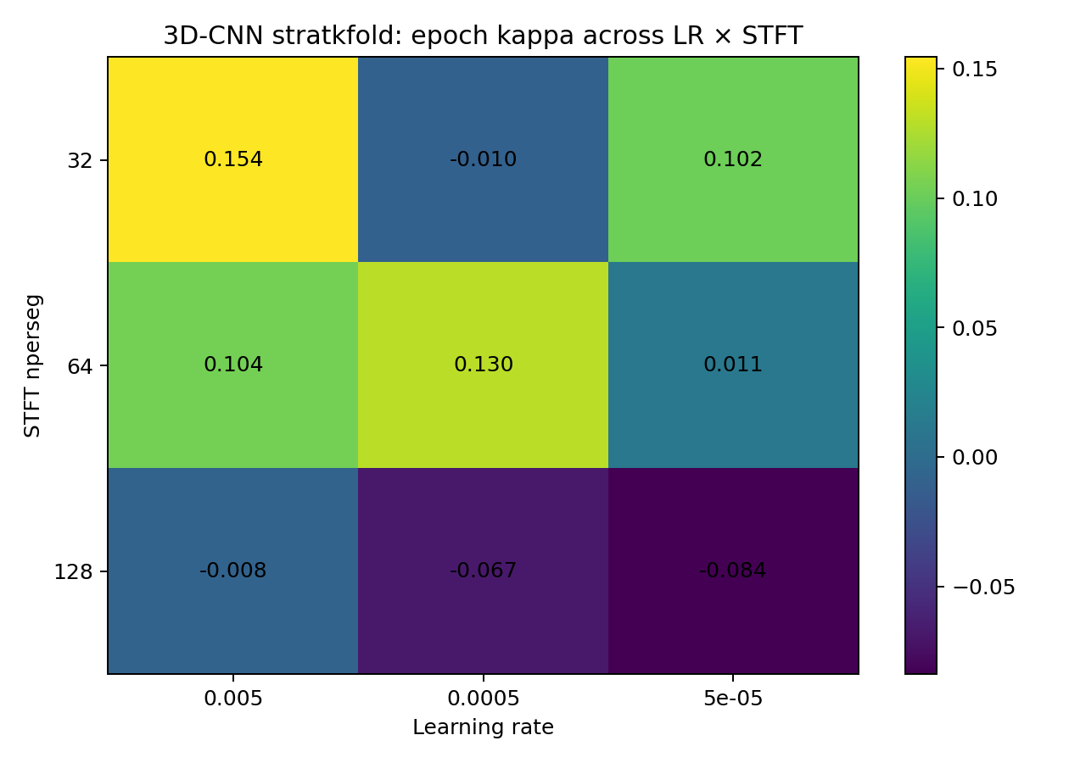
Figure S1. 3D-CNN epoch-level Cohen's Kappa across the learning-rate and STFT grid under Stratified Group 5-Fold validation.

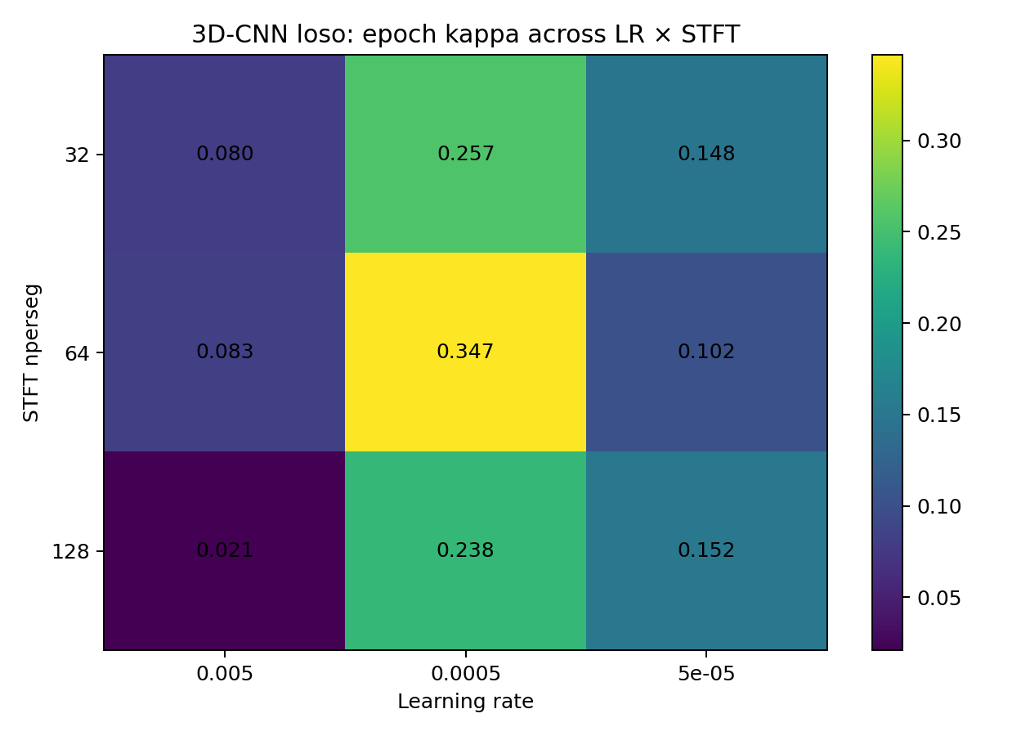
Figure S2. 3D-CNN epoch-level Cohen's Kappa across the learning-rate and STFT grid under LOSO validation.

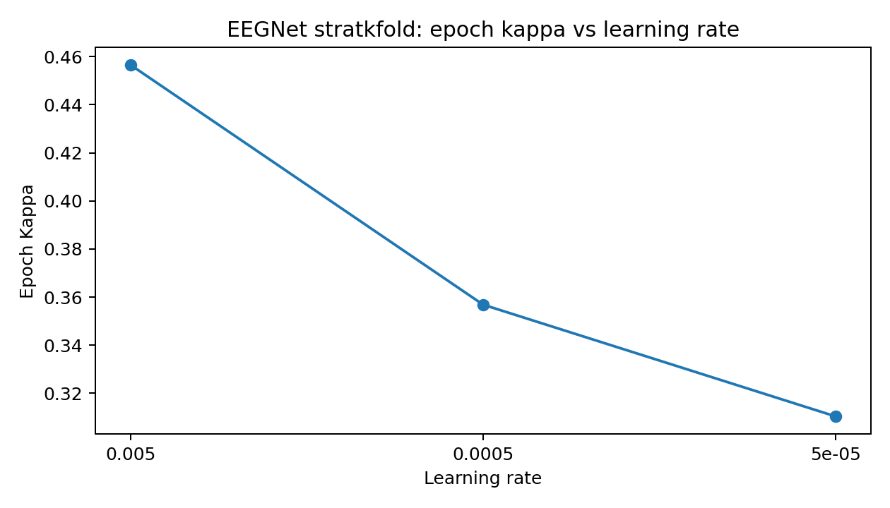
Figure S3. EEGNet epoch-level Cohen's Kappa across the three tested learning rates under Stratified Group 5-Fold validation.

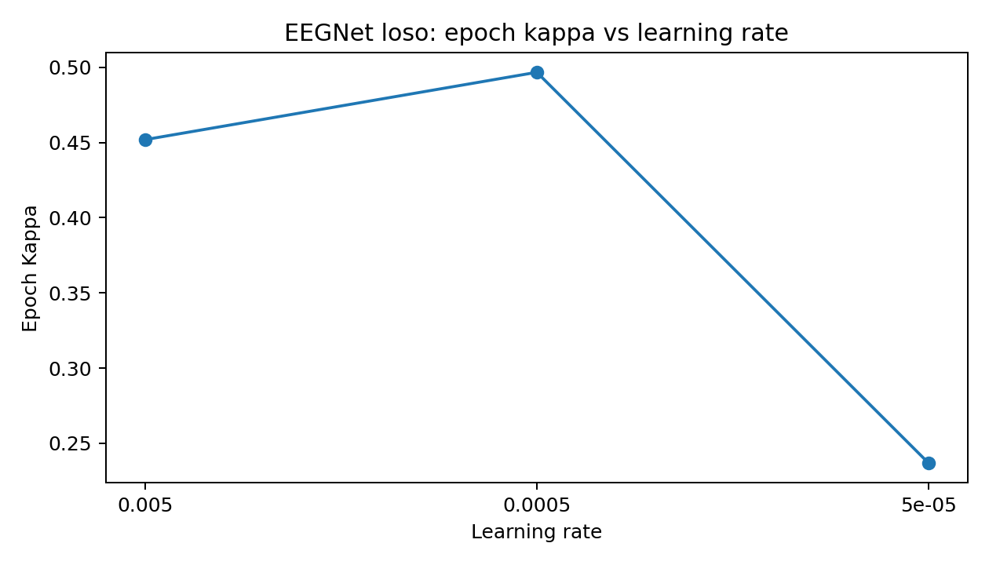
Figure S4. EEGNet epoch-level Cohen's Kappa across the three tested learning rates under LOSO validation.

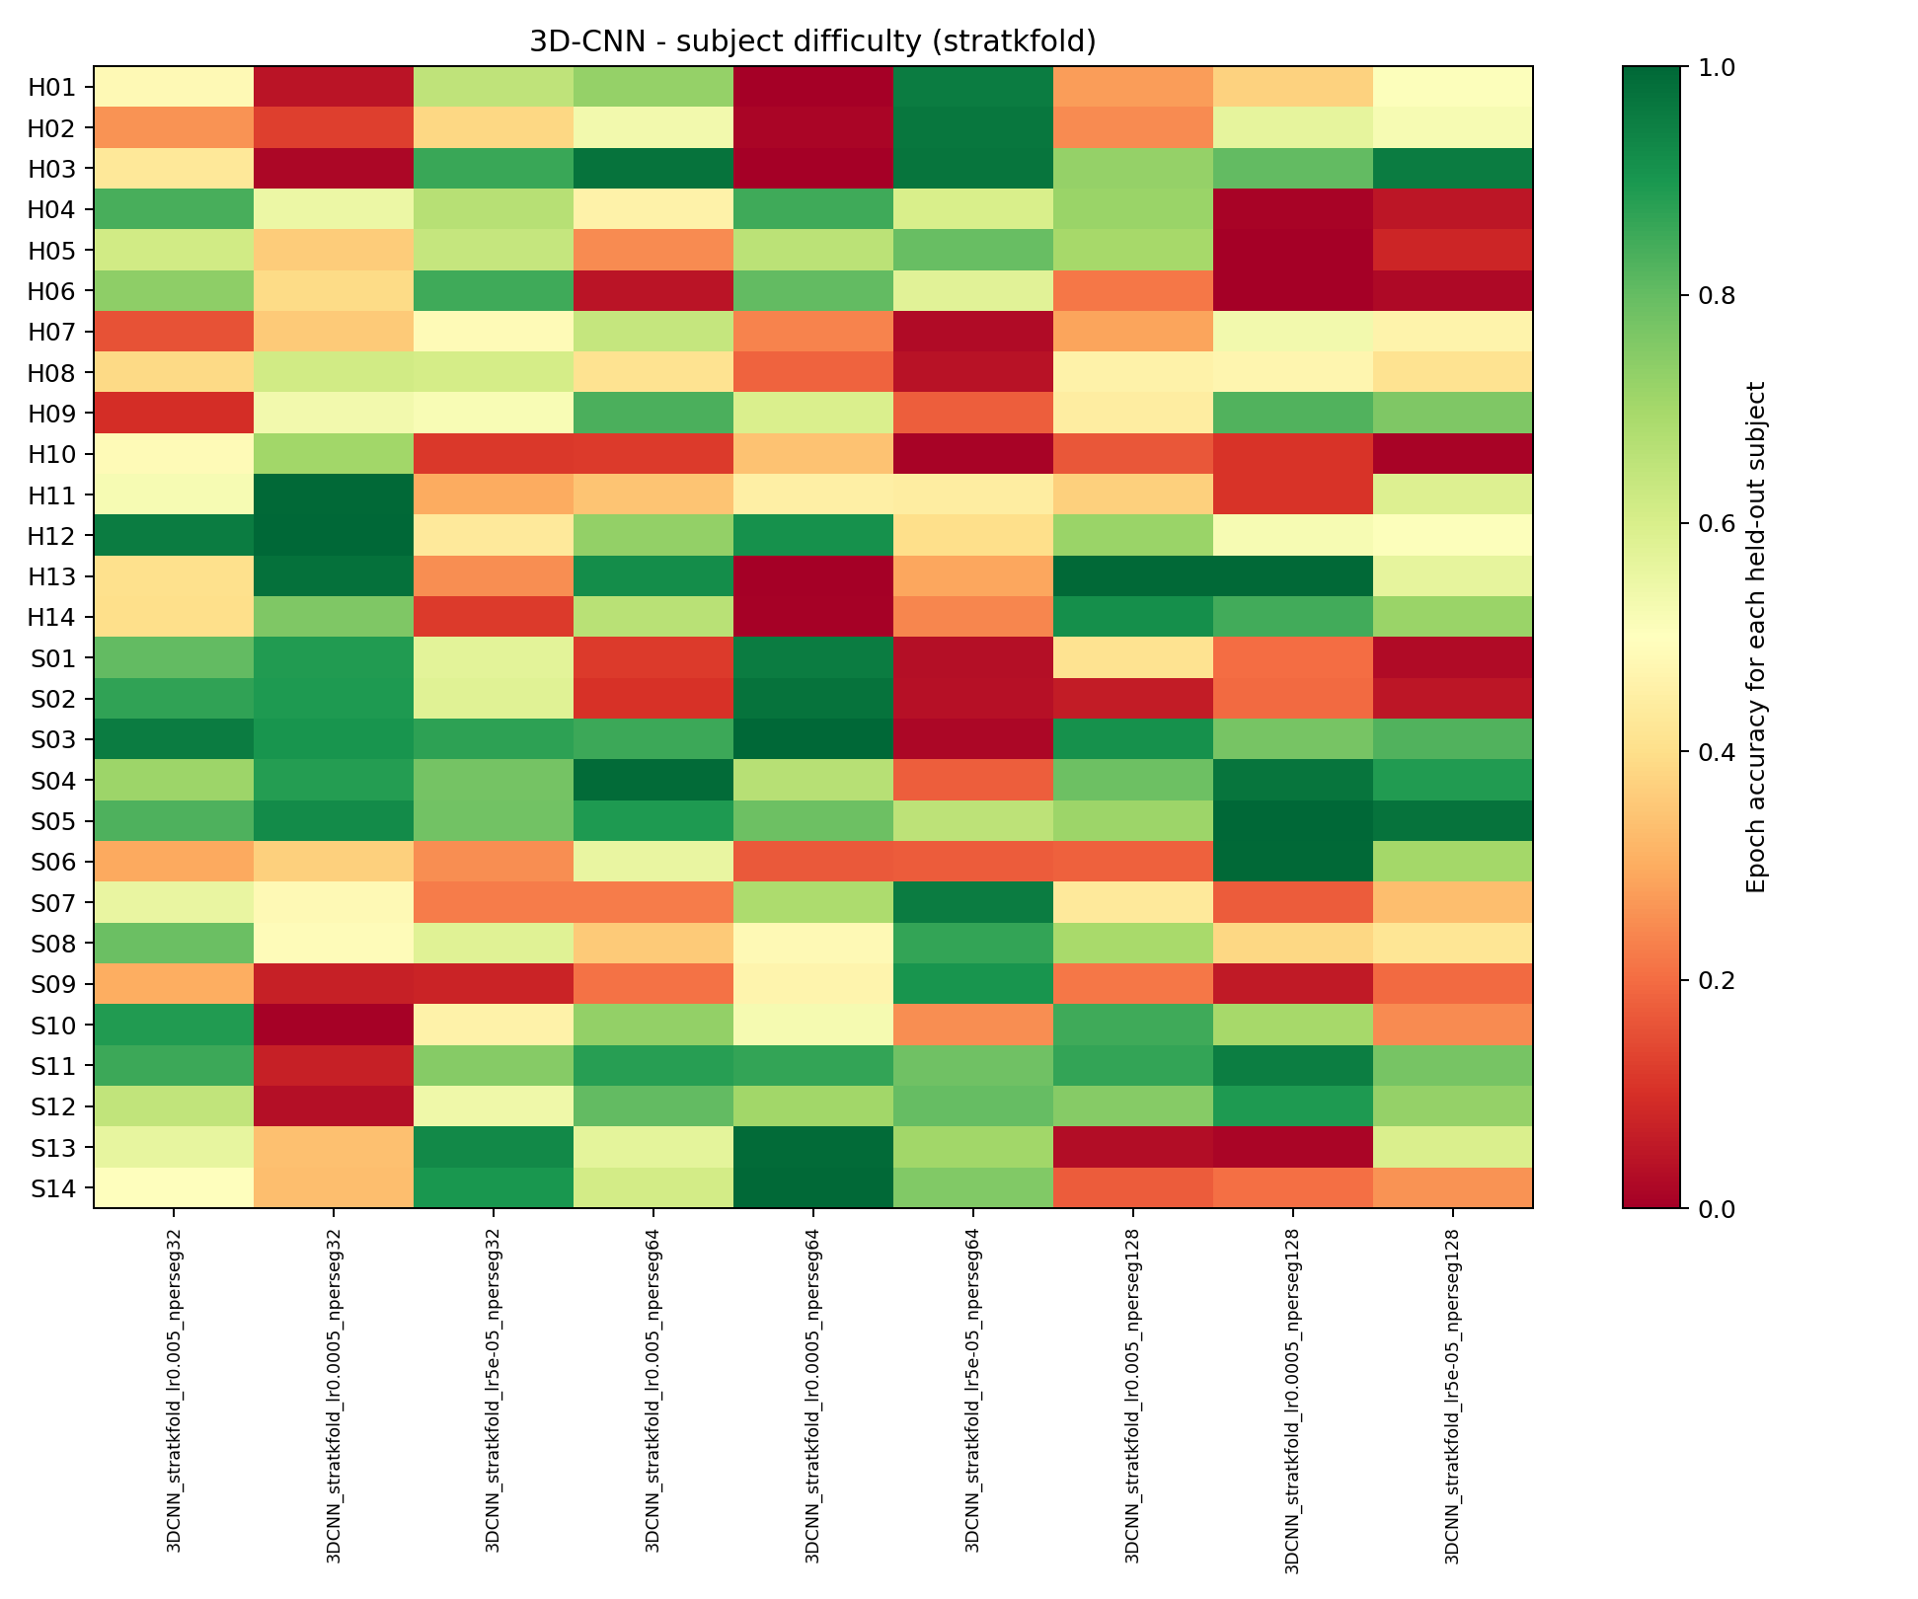
Figure S5. Held-out epoch accuracy for each subject across the nine 3D-CNN settings under Stratified Group 5-Fold validation. Each column is one learning-rate and STFT combination.

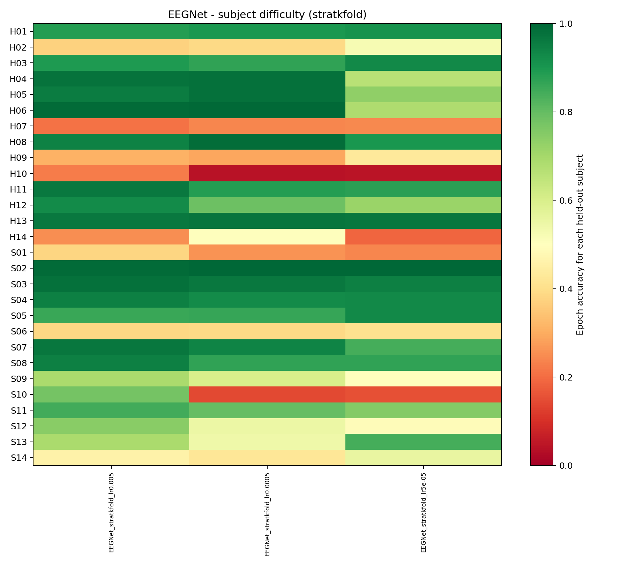
Figure S6. Held-out epoch accuracy for each subject across the three EEGNet learning rates under Stratified Group 5-Fold validation.

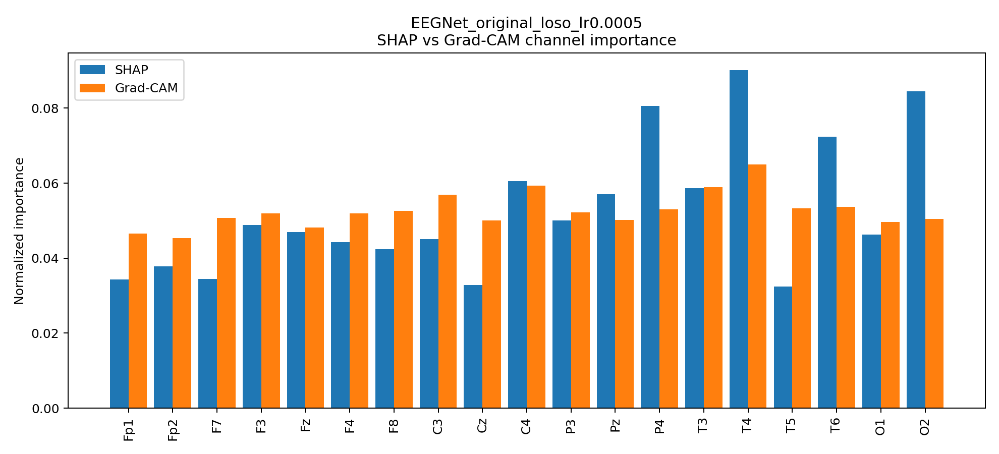
Figure S7. EEGNet SHAP and Grad-CAM channel importance for the original EEG under LOSO validation.

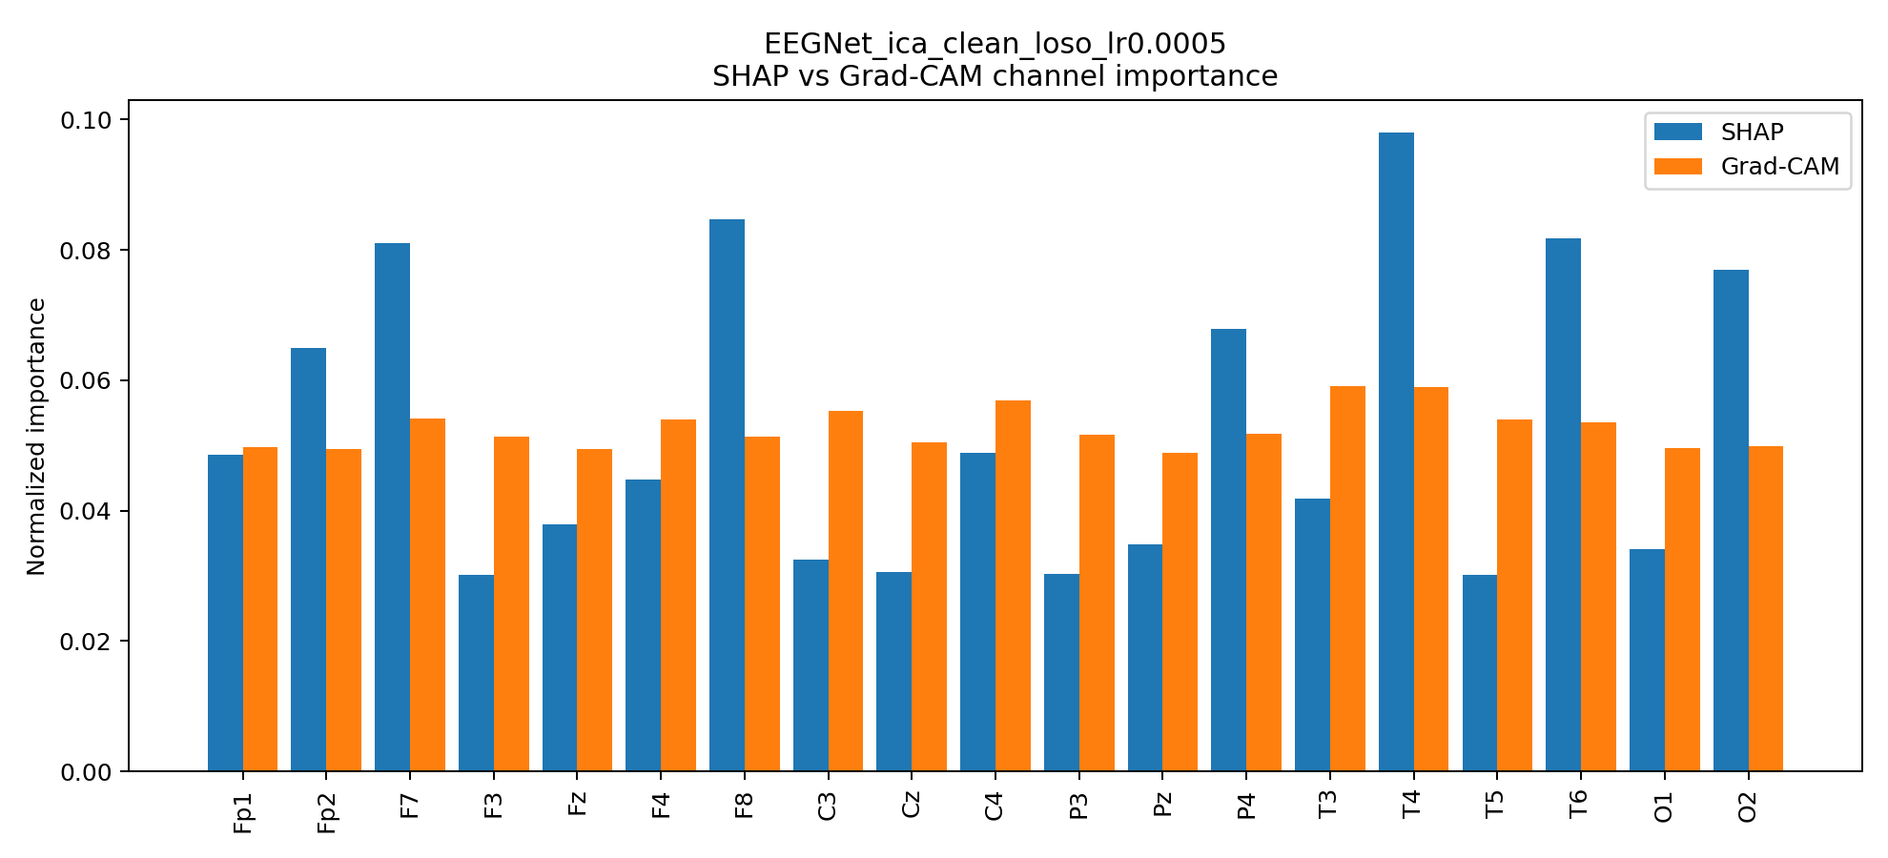
Figure S8. EEGNet SHAP and Grad-CAM channel importance for the ICA-cleaned EEG under LOSO validation.

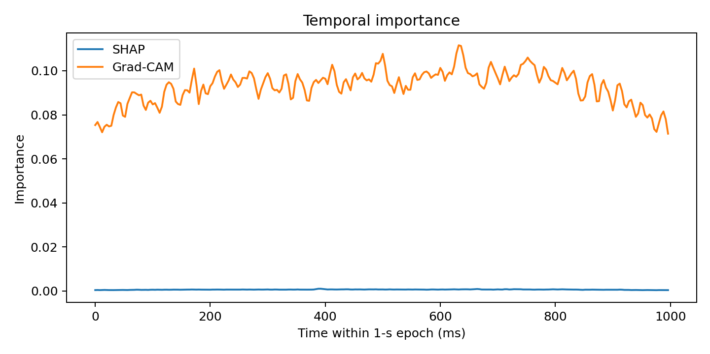
Figure S9. EEGNet SHAP and Grad-CAM importance across the 1-second epoch for the original EEG under LOSO validation.

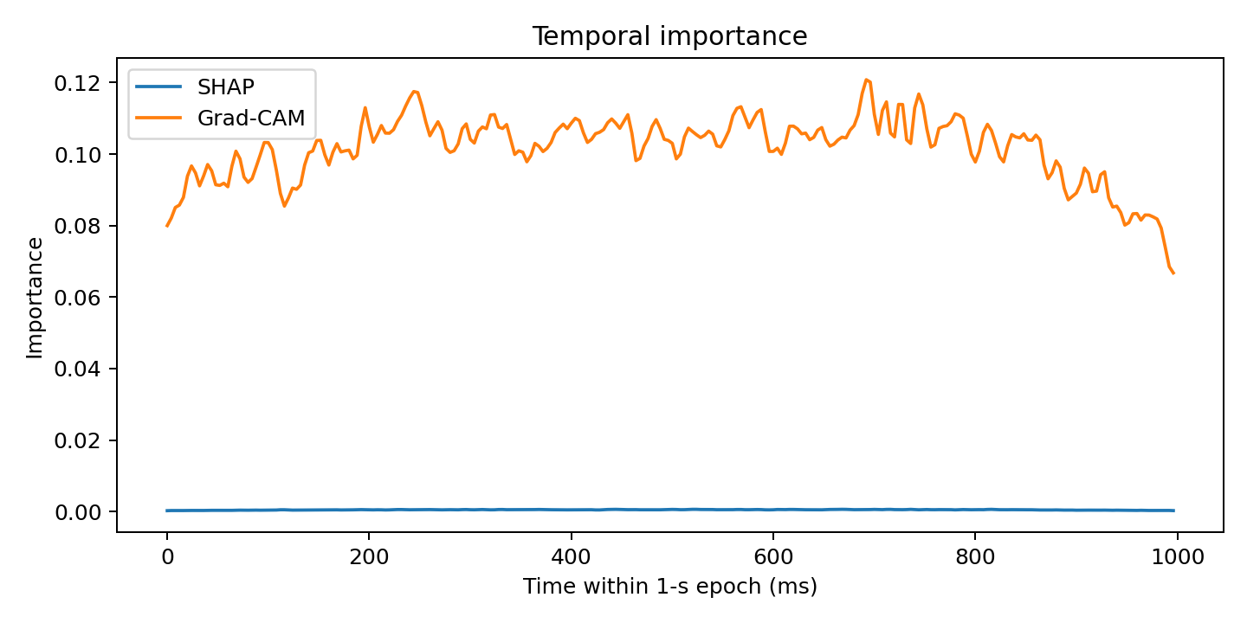
Figure S10. EEGNet SHAP and Grad-CAM importance across the 1-second epoch for the ICA-cleaned EEG under LOSO validation.

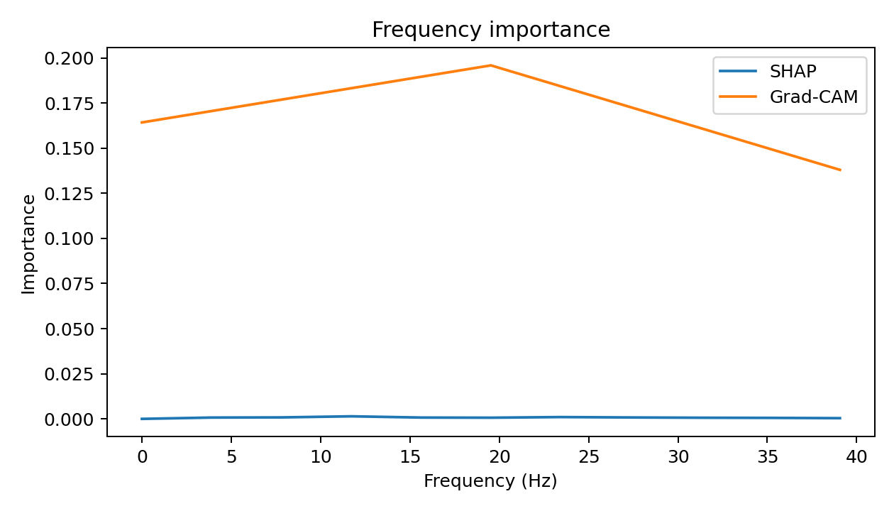
Figure S11. 3D-CNN SHAP and Grad-CAM importance across the 11 STFT frequency values for the original EEG under LOSO validation.

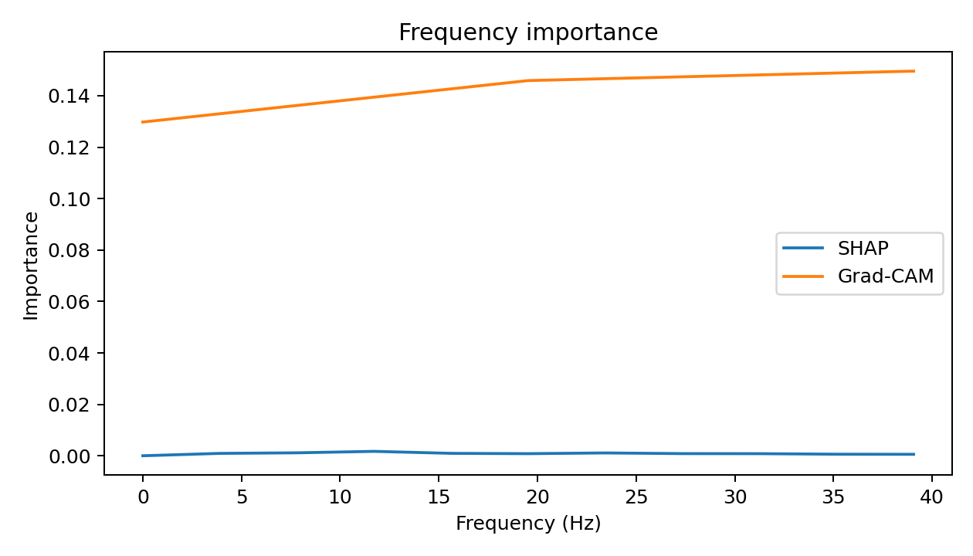
Figure S12. 3D-CNN SHAP and Grad-CAM importance across the 11 STFT frequency values for the ICA-cleaned EEG under LOSO validation.
Overall supporting conclusion. The detailed results support the short conclusion used in the revised manuscript. Some subjects are strongly affected by artifact removal, but this does not explain the overall weak 3D-CNN result under Stratified Group 5-Fold validation. Across the controlled checks, EEGNet gives stronger and more consistent results for this 28-subject dataset. The XAI results show which inputs influenced the trained models, but they should not be treated as confirmed clinical biomarkers.

